Chapter 19, Solution 95

Let 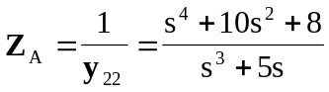

Using long division,
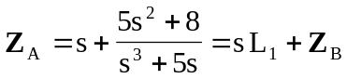

i.e. 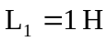 and 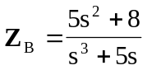
as shown in Fig (a).
L₁
y₂₂ = 1/Z_{A}
Z_{B}
(a)

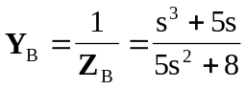

Using long division,
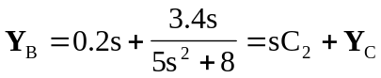

where 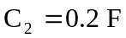 and 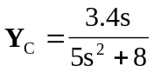
as shown in Fig. (b).
L₁
Y_{c} = 1/Z_{C}
(b)

C₂

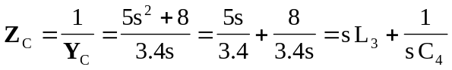

i.e. an inductor in series with a capacitor
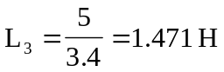 and 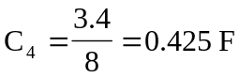

Thus, the LC network is shown in Fig. (c).
1 H
200 mF
425 mF
(c)

1.471 H

